Beginners Query

--1.Total Revenue: Calculates the total revenue generated from pizza orders

SELECT SUM(total_price) AS total_revenue

FROM pizza_sales;

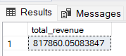

--2.Most Popular Pizza Names: Find the top 5 most ordered pizza names

SELECT TOP 5 pizza_name, COUNT(pizza_name) AS order_count

FROM pizza_sales

GROUP BY pizza_name

ORDER BY order_count DESC;

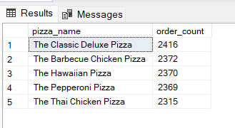

--3.Average Order Quantity: Calculate the average quantity of pizzas per order

SELECT AVG(quantity) AS avg_order_quantity

FROM pizza_sales;

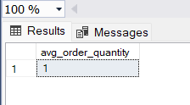

--4.Order Size Distribution: Determine the percentage distribution of order sizes (e.g. small, medium, large)

SELECT pizza_size, COUNT(pizza_size) AS size_count,

ROUND((COUNT(pizza_size) * 100.0 / (SELECT COUNT(*) FROM pizza_sales)), 2) AS percentage

FROM pizza_sales

GROUP BY pizza_size;

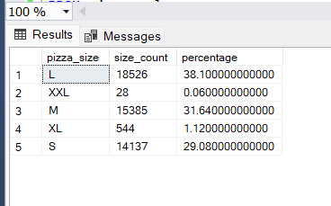

--5.Frequently Used Ingredients: Find the top 5 most frequently used pizza ingredients

SELECT TOP 5 pizza_ingredients, COUNT(pizza_ingredients) AS ingredient_count

FROM pizza_sales

GROUP BY pizza_ingredients

ORDER BY ingredient_count DESC;

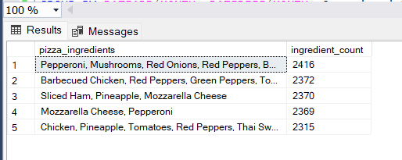

--6.Order Trends Over Time: Analyze the monthly order volume for the past year

SELECT DATEADD(MONTH, DATEDIFF(MONTH, 0, order_date), 0) AS month_start,

COUNT(order_id) AS order_count

FROM pizza_sales

WHERE YEAR(order_date) = 2015

GROUP BY DATEADD(MONTH, DATEDIFF(MONTH, 0, order_date), 0)

ORDER BY month_start;

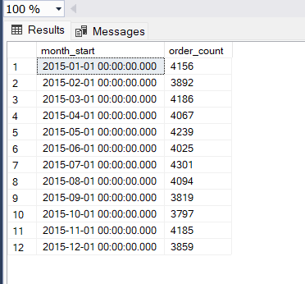

--7.High-Value Orders: List the top 5 orders with the highest total prices

SELECT TOP 5 pizza_name,order_id, total_price

FROM pizza_sales

ORDER BY total_price DESC;

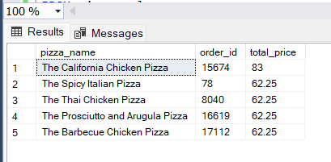

--8.Orders with the Most Quantity: Find the top 5 orders with the highest total quantity of pizzas

SELECT TOP 5 pizza_name,order_id, SUM(quantity) AS total_quantity

FROM pizza_sales

GROUP BY order_id,pizza_name

ORDER BY total_quantity DESC;

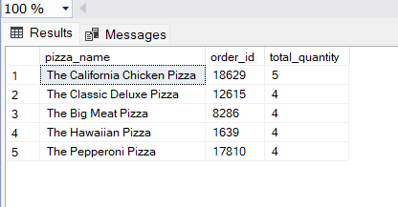

--9.Daily Order Trends: Analyze daily order volume for the last 30 days

SELECT CAST(order_date AS DATE) AS order_day, COUNT(order_id) AS order_count

FROM pizza_sales

WHERE order_date >= '2015-12-01' AND order_date < '2016-01-01'

GROUP BY CAST(order_date AS DATE)

ORDER BY order_day;

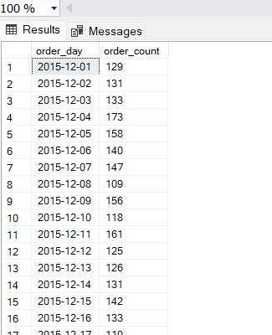

--10.Ingredient Usage Trends: Analyze the frequency of ingredient usage over time

SELECT DATEADD(MONTH, DATEDIFF(MONTH, 0, order_date), 0) AS month_start,

pizza_ingredients,

COUNT(pizza_ingredients) AS ingredient_count

FROM pizza_sales

WHERE order_date >= '2015-01-01' AND order_date < '2016-01-01'

GROUP BY DATEADD(MONTH, DATEDIFF(MONTH, 0, order_date), 0), pizza_ingredients

ORDER BY month_start, ingredient_count DESC;

